NORMAL FRAMEWORK OILSEALS TYPES CHART
OUTSIDE CHARACTERISTIC  LIP  CHARACTERISTIC |  | C | B | A
 |  | Characteristic:  Rubber outside, it’s applicable for the assembly of all kinds of material,including soft alloy or plasticity hole, even the surface of hole was hurt. | Characteristic:  Metal framework outside, it’s applicable for the assembling to the hole made by steel or casting iron. | Characteristic:  Bonded struction design, in order to improve the rigidity of oilseals, especially applicable for big size oilseals or need back assembly.
T | Double lips with spring  For rotation sealing  Low friction coefficient | 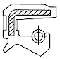  TC | 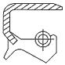  TB |   TA
S | Single lips with spring  For rotation sealing  Low friction coefficient | 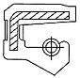  SC | 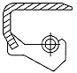  SB | 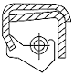  SA
K | Double lips without spring  For Rotation Sealing  Low friction coefficient | 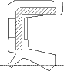  KC | 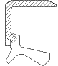  KB | 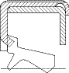  KA
V | Single lips without spring  For rotation sealing  Low friction coefficient | 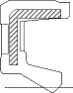  VC | 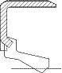  VB | 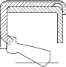  VA

